**Types of Housing**

The two types of rent regulation in New York State are rent control and rent stabilization. An individual tenant’s rights will depend, in part, upon which regulations apply, although some apartments may have multiple laws governing their tenancies. While tenants in rent regulated or government subsidized apartments have special rights, many rules and laws apply to both unregulated and regulated apartments.

*To find out whether an apartment is regulated, contact the New York State Division of Housing and Community Renewal at*[*portal.hcr.ny.gov/app/ask*](https://portal.hcr.ny.gov/app/ask)*.*

**Rent Regulated Housing**

**Rent Control**

Rent control limits the rent an owner may charge for an apartment and restricts the right of the owner to evict tenants. The rent control program applies to residential buildings constructed before February 1947 in municipalities that have not declared an end to the postwar rental housing emergency. Rent control is still in effect in New York City and parts of Albany, Erie, Nassau, Rensselaer, Schenectady, and Westchester counties.

For an apartment to be under rent control, the tenant or the tenant’s lawful successor (such as a family member, spouse, or adult lifetime partner) must have been living there continuously since before July 1, 1971 (and in some situations since April 1, 1953). When a rent controlled apartment is vacated in New York City or most other localities, it becomes rent stabilized. In New York City, each rent controlled apartment has a maximum base rent that is adjusted every two years to reflect changes in operating costs, but tenants’ rents cannot exceed a Maximum Collectible Rent, which is adjusted annually and based on an average of the past five years of Rent Guideline Board orders for one year leases or 7.5% (whichever is lower). Tenants may challenge increases if the Maximum Collectible Rent to the Maximum Base rent being charged by the landlord exceeds the legal regulated rent, the building has housing code violations, the owner’s expenses do not warrant an increase, or the owner is not maintaining essential services.

*Limits the rent an owner may charge for an apartment and restricts the right of the owner to evict tenants.*

*The rent control program applies to residential buildings constructed before February, 1947 in municipalities that have not declared an end to the postwar rental housing emergency.*

**Rent Stabilization**

In New York City, apartments are generally under rent stabilization if they are:

* An apartment that is not otherwise rent controlled in a building built before January 1, 1974 with six or more units;
* A formerly rent controlled apartment that became vacant without a lawful successor;
* In a building with three or more apartments constructed or extensively renovated on or after January 1, 1974 with special tax benefits, such as 421-a or J-51 tax abatements.

Outside New York City, rent stabilized apartments are generally found in buildings with six or more apartments that were built before January 1, 1974.

Local Rent Guidelines Boards in New York City, Nassau, Rockland, and Westchester counties set maximum rates for rent increases once a year which are effective for one or two year leases beginning on or after October 1 each year. Tenants in rent stabilized apartments are entitled to required essential services and lease renewals on the same terms and conditions as the original lease and may not be evicted except on grounds allowed by law.

As of June 15, 2019, other localities are now able to enact their own rent stabilization laws if the locality declares a housing emergency.

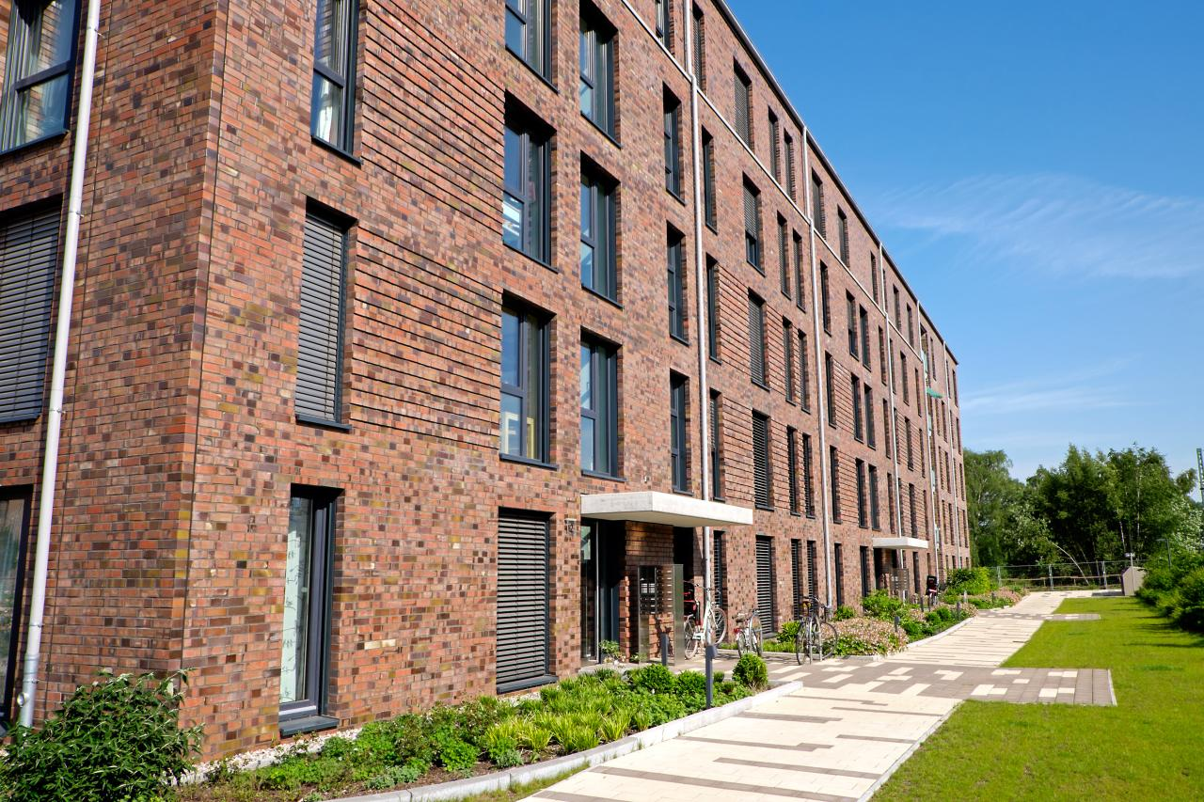

**Government-Financed Housing**

The Mitchell-Lama housing program provides rental and cooperative housing for middle-income tenants statewide. Tenants must meet eligibility requirements, including income, family size, and apartment size for both state and city-sponsored Mitchell-Lama developments.

Public Housing is a federally funded program in which state-chartered authorities develop and manage public housing developments, subject to federal, state, and local laws and regulations. Tenants in public housing are entitled to an administrative grievance process administered by the local housing authority before their tenancies may be terminated for cause.  However, tenants may be brought to court directly for nonpayment of rent without an administrative hearing.

**The Section 8 Housing Assistance Payments** program is a federal rent and mortgage subsidy program that assists eligible low-income or displaced families, senior citizens, and persons living with disabilities in obtaining housing nationwide. Families receive a rental subsidy, known as a housing assistance payment, or a mortgage subsidy toward payments to purchase a home, equal to the difference between their share of the rent, (based on their income) and the approved rent or mortgage for the unit. Eligible families and individuals are subject to statutory income limits.

**Special Types of Housing**

* **Manufactured and mobile home parks’** owners and tenants are governed by Real Property Law § 233 (“Mobile Homeowner’s Bill of Rights”). The Division of Housing and Community Renewal (DHCR) enforces compliance with this law.
* **New York City loft owners and tenants** are governed by Multiple Dwelling Law, Article 7-C, enforced by the New York City Loft Board.
* **New York City residential hotel** owners and tenants are governed by the rent stabilization law, enforced by the DHCR.

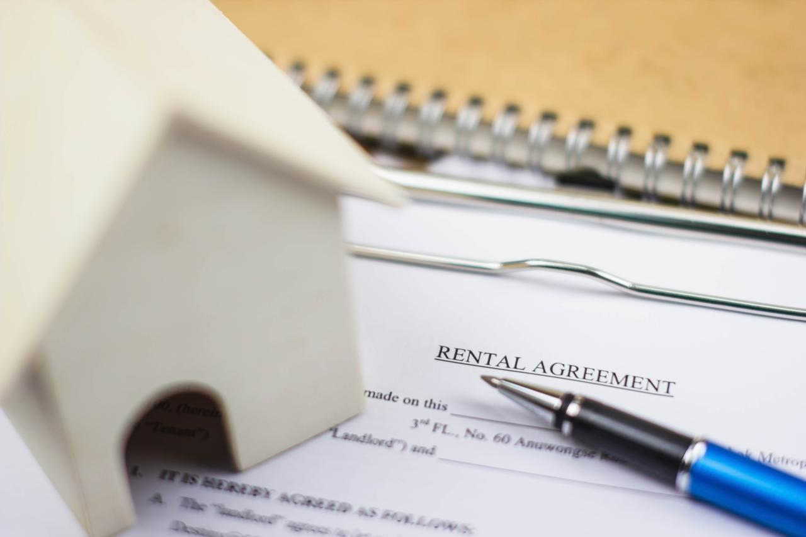

**Leases**

A lease is a contract between a landlord and a tenant that contains the terms and conditions of the rental. It cannot be changed while it is in effect unless both parties agree. Leases for apartments that are not rent stabilized may be oral or written. To avoid disputes, the parties may wish to enter into a written agreement. A party must sign the lease to be bound by its terms. An oral lease for more than one year cannot be legally enforced (*General Obligations Law § 5-701*).

At a minimum, leases should identify the premises, specify the names and addresses of the parties, the amount and due dates of the rent, the duration of the rental, the conditions of occupancy, and the rights and obligations of both parties. Except where the law provides otherwise, a landlord may rent on such terms and conditions as are agreed to by the parties. Any changes to the lease should be initialed by both parties.

New York City rent stabilized tenants are entitled to receive a fully executed copy of their signed lease from their landlords within 30 days of the landlord’s receipt of the lease signed by the tenant. The lease’s beginning and ending dates must be stated. Rent stabilized tenants must also be given a rent stabilization lease rider, prepared by DHCR, which summarizes their rights under the law and provides specific information on how the rent was calculated.



**Lease Provisions**

Leases must use words with common and everyday meanings and must be clear and coherent. Sections of leases must be appropriately captioned and the print must be large enough to be read easily. (*General Obligations Law § 5-702; NY C.P.L.R. § 4544.*)

The following lease provisions are not allowed:

* Exempting landlords from liability for injuries to persons or property caused by the landlord’s negligence, or that of the landlord’s employees or agents (*General Obligations Law § 5-321*);
* Waiving the tenant’s right to a jury trial in any lawsuit brought by either of the parties against the other for personal injury or property damage (*Real Property Law§ 259-c)*;
* Requiring tenants to pledge their household furniture as security for rent (*Real Property Law § 231)*;
* Exempting landlords from mitigating the damages of a tenant vacating the premises before the lease expires (*Real Property Law § 227-e)*;
* Waiving the Warranty of Habitability (*Real Property Law § 235-b)*; and
* Restricting a tenant from living with their immediate family members and/or one additional occupant and the occupant’s dependent children (*Real Property Law § 235-f)*.

If a lease states that the landlord may recover attorney’s fees and costs incurred, a tenant automatically has a reciprocal right to recover those fees as well (*Real Property Law § 234*). If the court finds a lease or any lease clause to have been unconscionable at the time it was made, the court may refuse to enforce the lease or the clause in question (*Real Property Law § 235-c*).



**Renewal Leases**

***Non-Rent Regulated Lease Renewals***

For non-rent regulated apartments, the landlord does not have to renew the lease.

A lease may contain an automatic renewal clause. In such cases, the landlord must give the tenant advanced notice of the existence of this clause between 15 and 30 days before the tenant is required to notify the landlord of an intention not to renew the lease. (*General Obligations Law § 5-905*).

If the landlord of the non-regulated unit intends to renew the lease with a rent increase of more than 5%, or does not intend to renew the lease, they must provide advanced written notice:

* If you have lived in your apartment two or more years, or if you have a two-year lease, your landlord must provide you with 90 days advanced written notice before raising your rent or not renewing your lease;
* If you have lived in your apartment for more than one year, but less than two years, your landlord must provide you with 60 days advanced notice before raising your rent or not renewing your lease; or
* If you have lived in your apartment for less than one year, or have a lease for less than one year, your landlord must provide you with 30 days advanced notice before raising your rent or not renewing your lease.



**Regulated Renewal Leases**

Rent stabilized tenants have a right to a one- or two-year renewal lease, which must be on the same terms and conditions as the prior lease, unless a change is mandated by a specific law or regulation. A landlord’s acceptance of a Section 8 subsidy is one such term which must be continued on a renewal lease. Landlords may refuse to renew a rent stabilized lease only under certain enumerated circumstances, such as when the tenant is not using the premises as their primary residence. For New York City rent stabilized tenants, the landlord must give written notice to the tenant of the right to renewal by mail or personal delivery not more than 150 days and not less than 90 days before the existing lease expires.

After the notice of renewal is given, the tenant has 60 days in which to accept. If the tenant does not accept the renewal offer within the prescribed time, the landlord may refuse to renew the lease and seek to evict the tenant through court proceedings. If the tenant accepts the renewal offer, the landlord has 30 days to return the fully executed lease to the tenant.



**Month-to-Month Tenants**

Non-rent regulated renters who do not have leases and pay rent on a monthly basis are called “month-to-month” tenants. Tenants who stay past the end of a lease are treated as month-to-month tenants if the landlord accepts a rent payment (*Real Property Law § 232-c*).

A month-to-month tenancy may be terminated by either party. If the landlord plans to terminate, they must give notice on the same timeline as terminating non-regulated leases (as described on the previous page). Outside of New York City, the tenant must give one month’s notice to terminate the lease.

Landlords do not need to explain why the tenancy is being terminated, they only need to provide notice that it is, and that refusal to vacate will lead to eviction proceedings. Such notice does not automatically allow the landlord to evict the tenant. A landlord may raise the rent of a month-to-month tenant with the consent of the tenant. If the tenant does not consent, however, the landlord can terminate the tenancy by giving appropriate notice. (*Real Property Law § 232-a and § 232-b*).



**Rent**

**Rent Charges**

When an apartment is not rent regulated, a landlord is free to charge any rent agreed upon by the parties. If the apartment is subject to rent regulation, the initial rent and subsequent rent increases are set by law, and may be challenged by a tenant at any time. However, recovery of rent overcharge is limited to either four or six years preceding the complaint depending on when the complaint is made.

**Late Fees**

A rent payment can only be considered late if it is received more than five days after it is due. The most your landlord can charge as a late fee is $50 or 5% of your monthly rent, whichever is less (*Real Property Law § 238-a*).

Tenants can use the failure by the landlord to provide this notice as an affirmative defense in a nonpayment of rent case.

**Receipts**

Landlords must provide tenants with a written receipt when rent is paid by cash, money order, cashier’s check, or in any form other than the personal check of a tenant. Tenants paying rent by personal check may request in writing a rent receipt from the landlord. The receipt must state the payment date, the amount, the period for which the rent was paid, and the apartment number. The receipt must be signed by the person receiving the payment and state his or her title. (*Real Property Law § 235-e*). After the tenant requests a receipt one time, the landlord must provide a receipt every month. The landlord also must keep proof of cash rent receipts for 3 years.

**Rent Increases**

***Rent Increases for Non-Regulated Apartments***

If the landlord of a non-regulated unit intends to increase the rent by more than 5%, they must provide advanced written notice of either 30, 60, or 90 days depending on how long the tenant has been in occupancy (see section on Renewal Leases).

**Rent Increases for Regulated Apartments**

Maximum rent increases for rent stabilized apartments are set each year by local Rent Guidelines Boards.

Landlords are no longer permitted to increase rent in a rent-regulated unit by 20% when it becomes vacant (the ‘vacancy bonus’). The related ‘longevity bonus,’ (when the departing tenant has lived in the unit for eight years or more) is also prohibited.

Additionally, in most cases landlords are no longer allowed to take an apartment out of rent regulation when the rent exceeds the “high-rent threshold” and the apartment becomes vacant. Also, deregulation is no longer permitted in most cases if the tenant is considered “high-income.” (There are a small number of exceptions to the high-rent and high-income deregulation prohibitions for certain new buildings that receive tax abatements.)

Apartments that were deregulated before June 14, 2019 will continue to be so.

Tenants should check their rent history to potentially challenge both the deregulation of their apartment and the rent currently being charged. To check your rent history, call the Office of Rent Administration at [1-833-499-0343](tel:1-833-499-0343), or visit [portal.hcr.ny.gov/app/ask](https://portal.hcr.ny.gov/app/ask).

Other inquiries, such as those related to leases, services and rent increases, may be directed to Rent Connect at <https://rent.hcr.ny.gov/RentConnect/Welcome>.

**Substantial Improvements in Rent-Regulated Units:**

***Major Capital Improvements (MCIs)***

For certain types of building-wide major capital improvements (MCIs) that benefit all of the tenants in a building (such as the replacement of a boiler or plumbing) the landlord may apply to DHCR to increase the rent of their rent stabilized tenants.  The amount that a landlord can raise tenants’ rents due to MCIs is now capped at 2% of their current rent per year, and there is no retroactive amount. This cap applies to MCI increases not collected yet that were approved after June 16, 2012. Additionally, MCI increases are now temporary and will be removed from tenants’ rents after 30 years.

MCI increases cannot be added to your rent if there are any “hazardous” or “immediately hazardous” violations at your building. Your landlord must fix these violations before any MCI can be authorized by state regulators.

MCI increases are not permitted if fewer than 35% of the apartments in the building are rent regulated.

**Individual Apartment Improvements (IAIs)**

Landlords are also permitted to increase rents for improvements made to individual apartments (for example, new flooring, new fixtures or other improvements). Typically, these improvements occur while the unit is vacant, but can also be made in occupied units with written approval from the tenant.  To increase the rent because of an IAI, the landlord must take before and after photos, maintain permanent records of the improvement, and submit documentation to the state.

The amount by which the landlord can increase the rent is determined by how much the improvements cost.

* In buildings that contain more than 35 apartments, the landlord can collect a permanent rent increase equal to 1/180th of the cost of the improvement (maximum $83.33).
* In buildings that contain 35 apartments or less, the landlord may collect a permanent rent increase equal to 1/168th of the cost of the IAI (maximum $89.29).

Before a landlord can collect a rent increase due to an IAI, they must first fix any “hazardous” or “immediately hazardous” violations in the apartment.

For occupied units, the tenant’s written consent must be on a DHCR form.    
The landlord must use licensed contractors not affiliated by common ownership between the contractor and the landlord to perform any work it intends to count as an IAI.

A landlord can only claim up to three IAIs in a 15-year period, total costs eligible for a rent increase calculation cannot exceed $15,000. IAIs are temporary and must be removed from your rent after 30 years.

A landlord also may increase the rent because of hardship or increased labor costs.

**Rent Increase Exemptions**

Tenants who are senior citizens (62 or older) or living with a disability and living in rent regulated, Low-Income Housing Tax Credit (LIHTC), Limited Dividend, Redevelopment, Housing Development Fund Corporation (HDFC), or Mitchell-Lama cooperatives and rentals, may be granted certain exemptions from rent increases. Tenants may determine whether they qualify for a Senior Citizen Rent Increase Exemption (SCRIE) or a Disability Rent Increase Exemption (DRIE) by calling the NYC Department of Finance at (212) 639-9675 or visiting the walk-in center located at 66 John Street, 3rd Floor, New York, NY 10038. For SCRIE/DRIE applications for HDFC or Mitchell-Lama apartments, contact the NYC Department of Housing Preservation and Development (HPD) at (212) 863-8494. Tenants in other parts of New York State may contact DHCR to determine their eligibility.

**Rent Increases for Rent Controlled Tenants**

In the past, landlords could raise rents for rent controlled tenants up to 7.5% every year, in addition to fuel pass-along charges (plus MCI and/or IAI increases).

Now, a landlord is limited to increasing a rent-controlled tenant’s rent by the average of the five most recent Rent Guidelines Board annual rent increases for one-year lease renewals, or 7.5% (whichever is less).

Landlords may no longer charge fuel costs to rent-controlled tenants.

If you believe your landlord is not following the law related to rent increases, you can make a complaint to the New York State Department of Homes and Community Renewal at hcr.ny.gov.

**Preferential Rent**

For rent stabilized tenants paying a rent lower than the legal regulated rent (called a preferential rent), the landlord is no longer allowed to revoke it and raise the rent to the higher legal regulated rent. This means that your landlord cannot raise your preferential rent more than the percentage set by the Rent Guidelines Board, plus any charges for MCIs or IAIs if they apply.

The lease should show your legal rent, and if you have a preferential rent, it may be shown in the section of the lease that says: “Lower rent to be charged, if any.”

**Rent Overcharges**

In New York City and certain communities in Nassau, Rockland, and Westchester counties where rent stabilization or rent control laws apply, the landlord may not charge more than the legal regulated rent. Landlords must register each rent stabilized apartment with the DHCR and provide tenants annually with a copy of the registration statement. Tenants may also get a copy of the rent history for their apartment directly from the DHCR. The tenant may also be entitled to recover interest, plus reasonable costs and attorney’s fees, for overcharges after June 14, 2019.

Generally, the penalty for a rent overcharge is the amount an owner collected above the legal regulated rent, plus accrued interest. If the overcharge is willful, the landlord is liable for a penalty of three times the amount of the overcharge. The landlord has the burden of proving that the overcharge was not willful. Tenants who believe they are being overcharged should contact the DHCR and/or an attorney.

**Rent Security Deposits**

At the beginning of their tenancy, all tenants can be required to give their landlord a security deposit, but it is limited to no more than one month’s rent. The one-month limit means that a landlord cannot ask for last month’s rent and a security deposit. However, if the lease is renewed at a greater amount or the rent is increased during the term of the lease, the landlord is permitted to collect additional money from the tenant to bring the security deposit up to the new monthly rent. Landlords, regardless of the number of units in the building, must treat the deposits as trust funds belonging to their tenants and they may not co-mingle deposits with their own money.

Landlords of buildings with six or more apartments must put all security deposits in a New York bank account earning interest at the prevailing rate. Each tenant must be informed in writing of the bank’s name and address and the amount of the deposit. Landlords are entitled to collect annual administrative expenses of 1% of the deposit. All other interest earned on the deposits belongs to the tenant. Tenants must be given the option of having this interest paid to them annually, applied to rent, or paid at the end of the lease term. If the building has fewer than six apartments, a landlord who voluntarily places security deposits in an interest-bearing bank account must also follow these rules.

For example: A tenant pays a security deposit of $1,000. The landlord places the deposit in an interest-bearing bank account paying 1.5%. At the end of the year the account will have earned interest of $15.00. The tenant is entitled to $5.00 and the landlord may retain $10.00, 1% of the deposit, as an administrative fee.

A landlord may use the security deposit as a reimbursement for any unpaid rent, or the reasonable cost of repairs beyond normal wear and tear, if the tenant damages the apartment.

**Getting Your Security Deposit Back – Non-Regulated Units**

For tenants in units that are not rent stabilized or rent controlled, the landlord must return the security deposit within 14 days of the tenant moving out.

If the landlord takes any money out of the security deposit for damages, they must provide an itemized “receipt” describing the damage and its cost. If the landlord does not provide this receipt within 14 days of the tenant moving out, they must return the entire security deposit, whether there is damage or not.

Tenants planning to move out can ask their landlord to inspect the apartment (or rental home or other type of home rental) before the move-out date. They must allow the tenant to be present during the inspection. At that inspection, the landlord must tell the tenant what needs to be fixed or cleaned. The tenant then has the opportunity to fix any issues to prevent the landlord from keeping part or all of the security deposit.

If the landlord deliberately breaks this law, the tenant may be entitled to up to twice the amount of the security deposit.

**Note: Currently, these laws only apply to tenants in non-rent regulated units. For rent regulated units, the landlord must return the security deposit to the tenant, less any lawful deduction, at the end of the lease or within reasonable time thereafter, whether or not the tenant asks for its return. Upon vacating, the tenant should leave the apartment in clean condition, removing all personal belongings and trash from the apartment, and making any minor repairs needed.**

Our office may be able to help you get back your rent security deposit. To request help, simply file a rent security complaint form with: Office of the New York State Attorney General Bureau of Consumer Frauds and Protection. You may access this form at [formsnym.ag.ny.gov/OAGOnlineSubmissionForm/faces/OAGRSHome](https://formsnym.ag.ny.gov/OAGOnlineSubmissionForm/faces/OAGRSHome).

**Sale of Building**

If the building is sold, the landlord must transfer all security deposits to the new owner within five days or return the security deposits to the tenants. Landlords must notify the tenants, by registered or certified mail, of the name and address of the new owner.

Purchasers of rent stabilized buildings are directly responsible to tenants for the return of security deposits and any interest. This responsibility exists whether or not the new owner received the security deposits from the former landlord.

Purchasers of rent controlled buildings or buildings containing six or more apartments where tenants have written leases are directly responsible to tenants for the return of security deposits and interest in cases where the purchaser has “actual knowledge” of the security deposits. The law defines specifically when a new owner is deemed to have “actual knowledge” of the security deposits (*General Obligations Law, Article 7, Title 1*).

When problems arise regarding security deposits, tenants should first try to resolve them with the landlord before taking other action. If a dispute cannot be resolved, tenants may contact the nearest local office of the Attorney General, listed at the end of this booklet.

*If the building is sold, the landlord must transfer all security deposits to the new owner within five days or return the security deposits to the tenants.*

*Landlords must notify the tenants, by registered or certified mail, of the name and address of the new owner.*

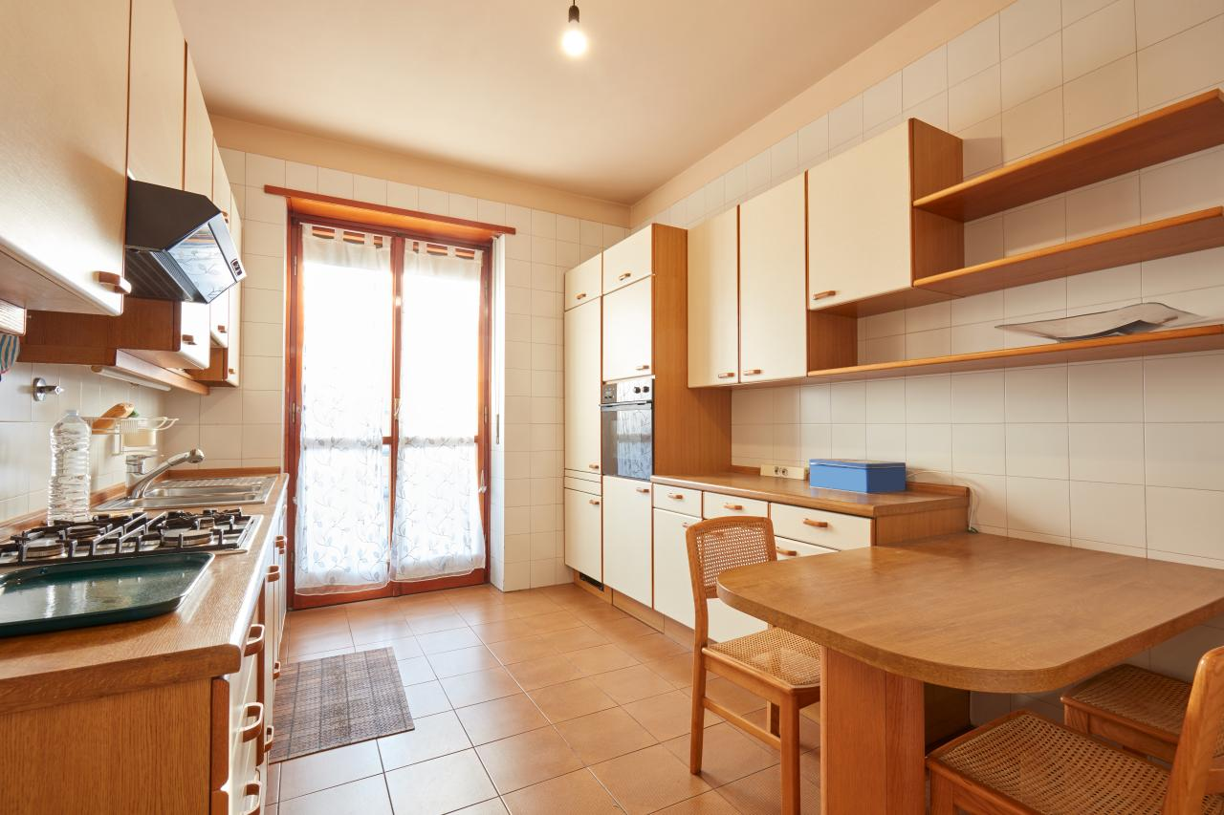

**Lease Succession or Termination**

**Subletting or Assigning Leases**

Subletting and assignment are methods of transferring the tenant’s legal interest in an apartment to another person. Here are the differences between the two.

**Sublet**

To sublet means that the tenant is temporarily leaving the apartment and therefore is transferring less than the entire interest in the apartment. A tenant who subleases an apartment is called the prime tenant and the person temporarily renting the premises is the subtenant.

Tenants in buildings with three or fewer apartments do not have a right to sublet. They can ask the landlord to sublet but the landlord does not have to agree. If the landlord unreasonably withholds their consent to sublet, the tenant’s only remedy is to be let out of their lease after 30 days’ notice to the landlord.  
  
Tenants in buildings with four or more apartments have the right to sublet with the landlord’s advance consent. Any lease provision restricting a tenant’s right to sublease is void as a matter of public policy. If the landlord consents to the sublet, the tenant remains liable to the landlord for the obligations of the lease, including all future rent. If the landlord denies the sublet on reasonable grounds, the tenant cannot sublet, and the landlord is not required to release the tenant from the lease. If the landlord denies the sublet on unreasonable grounds, the tenant may sublet anyway. If a lawsuit results, the tenant may recover court costs and attorney’s fees if a judge rules that the landlord denied the sublet in bad faith *(Real Property Law § 226-b(2)*).

These steps must be followed by tenants wishing to sublet:

1. The tenant must send a written request to the landlord by certified mail, return-receipt requested. The request must contain the following information: (a) the length of the sublease; (b) the name, home and business address of the proposed subtenant; (c) the reason for subletting; (d) the tenant’s address during the sublet; (e) the written consent of any co-tenant or guarantor; and (f) a copy of the proposed sublease together with a copy of the tenant’s own lease, if available.
2. Within ten days of mailing this request, the landlord may ask the tenant for additional information. Any request for additional information may not be unduly burdensome.
3. Within 30 days of the mailing of the tenant’s sublet request or within 30 days of the landlord’s request for additional information, whichever is later, the landlord must send the tenant a notice of consent, or if consent is denied, the reasons for denial. A landlord’s failure to send this written notice is considered consent to sublet (*Real Property Law § 226-b(2)*).

Additional requirements limited to rent stabilized tenants:

* The rent charged to the subtenant cannot exceed the stabilized rent, plus a 10% surcharge payable to the tenant for a furnished sublet. Additionally, the stabilized rent payable to the owner, effective for the duration of the sublet only, may be increased by a “sublet allowance” which is set by the Rent Guidelines Board. A subtenant who is overcharged may file a complaint with DHCR or may sue the prime tenant in court to recover any overcharge plus interest, attorneys’ fees, and treble damages where applicable (*9 NYCRR § 2525.6(e)*);
* The prime tenant must establish that the apartment has been maintained as a primary residence at all times and must demonstrate intent to reoccupy it at the end of the sublet; and
* The prime tenant, not the subtenant, retains the rights to a renewal lease and any rights resulting from a co-op conversion. The term of a sublease may extend beyond the term of the prime tenant’s lease. The tenant may not sublet for more than two years within any four year period (Real Property Law § 226-b; 9 NYCRR § 2525.6). Frequent or prolonged periods of subletting may be grounds for a landlord to seek possession of rent stabilized premises on the basis of non-primary residence (*9NYCRR § 2520.6(u)*).

**Assign a Lease**

To assign means that the tenant is transferring the entire interest in the apartment lease to someone else and permanently vacating the premises. The right to assign the lease is much more restricted than the right to sublet. A sublet or assignment which does not comply with the law may be grounds for eviction.

A tenant may not assign the lease without the landlord’s written consent. The landlord may withhold consent without cause. If the landlord reasonably refuses consent, the tenant cannot assign and is not entitled to be released from the lease. If the landlord unreasonably refuses consent, the tenant is entitled to be released from the lease within 30 days from the date the request was given to the landlord (*Real Property Law § 226-b(1)*).

**Apartment Sharing**

It is unlawful for a landlord to restrict occupancy of an apartment to the named tenant in the lease or to that tenant and immediate family. When the lease names only one tenant, that tenant may share the apartment with immediate family, one additional occupant, and the occupant’s dependent children provided the tenant or the tenant’s spouse occupies the premises as their primary residence. When the lease names more than one tenant, these tenants may share their apartment with immediate family; and, if one of the tenants named in the lease moves out, that tenant may be replaced with another occupant and the dependent children of the occupant. At least one of the tenants named in the lease or that tenant’s spouse must occupy the shared apartment as a primary residence.

A tenant must inform the landlord of the name of any occupant within 30 days of the occupant moving into the apartment or 30 days of a landlord’s request for this information. If the tenant named in the lease moves out, the remaining occupant has no right to continue in occupancy without the landlord’s express consent.

Landlords may limit the total number of people living in an apartment to comply with legal overcrowding standards (*Real Property Law § 235-f*).

**Lease Succession Rights**

Family members living in an apartment not covered by rent control, rent stabilization, or other housing governed by a regulatory agreement generally have no right to succeed a tenant who dies or permanently vacates the premises. The rights of a family member living in a rent controlled or rent stabilized apartment to succeed a tenant of record who dies or permanently vacates are covered by DHCR regulations. Under these regulations, a “family member” is defined as husband, wife, son, daughter, stepson, stepdaughter, father, mother, stepfather, stepmother, brother, sister, grandfather, grandmother, grandson, granddaughter, father-in-law, mother-in-law, son-in-law, or daughter-in-law of the tenant; or any other person residing with the tenant in the apartment as primary resident who can prove emotional and financial commitment and interdependence with the tenant *(9 NYCRR § 2520.6(o)(2)*).

Minimum Residency — A family member would succeed to the rights of the tenant of record upon the tenant’s permanent departure or death, provided the family member lived with such a primary resident either

(1) not less than two years (one year in the case of senior citizens and persons living with a disability persons), or

(2) from the commencement of the tenancy or the relationship, if the tenancy or relationship was less than two years— or one year, in the case of senior citizens and tenants living with a disability (*9 NYCRR § 2523.5*).

The minimum residency requirements will not be considered interrupted by any period during which the “family member” temporarily relocates because he or she is engaged in active military service, is enrolled as a full-time student, is not living in the residence because of a court order, is temporarily relocated for employment, is hospitalized; or other reasonable grounds.

To ensure that the landlord is aware of all persons residing in the apartment who may be entitled to succession rights or protection from eviction, a tenant may wish to submit a notice listing all additional occupants to the landlord (*9 NYCRR § 2523.5(b)(2)*). The landlord may request from the tenant, but not more than once in any twelve month period, the names of all persons residing in the apartment.

Remaining family members living in government-financed housing (such as a public development, an apartment owned by the local municipality, or in an apartment where the prime tenant had Section 8 Rental Assistance) and where the named tenant of record has died or moved out, may also have the right to succeed to that tenant’s lease and/or rent subsidy. Family members seeking succession rights in these circumstances must check the applicable federal and municipal regulations and the local public housing authority rules to determine if they meet the eligibility requirements. Under federal regulations, persons alleging they are remaining family members of a tenant are entitled to a grievance hearing before eviction if they can make a plausible claim to such status.

**Lease Termination**

If you leave your apartment or other rental home before your lease ends, your landlord must make a good-faith effort to fill the vacancy. If the landlord finds a new tenant and the new tenant’s rent is equal or higher to your rent, your lease is considered terminated and you are no longer liable for the rent.

**Senior Citizen or Individuals Living with a Disability Lease Termination**

Tenants or their spouses or dependents living with them who are 62 or older, or who will turn 62 during the term of their leases, or who are living with a disability as defined in Executive Law 292 (21); are entitled to terminate their leases if:

* They are certified by a physician as being no longer able, for medical reasons, to live independently and will move to the residence of a family member; or
* They relocate to an adult care facility, a residential health care facility, subsidized low- or moderate-income housing, or other housing for seniors or persons living with a disability.*Real Property Law §227-a(1)*.

When given notice of the tenant’s intention to move into one of the above facilities, the landlord must release the tenant from liability to pay rent for the balance of the lease and adjust any payments made in advance.

Written notice must include:

* Termination date: The law says, the termination date must be effective no earlier than thirty days after the date on which the next rental payment is due (after the notice is delivered). The notice is considered delivered five days after mailing. For example: if the notice to the landlord is mailed on April 5, the notice is deemed received April 10. Since the next rental payment (after April 10) is due May 1, the earliest lease termination date will be effective June 1;
* A physician’s certification that the person is no longer able to live independently for medical reasons; and
* For senior citizens breaking a lease, the notice must be accompanied by a notarized statement from a family member stating both that the senior is related and will be moving into his or her residence for at least six months if admission is pending with documentation of pending admission, or admission to one of the above mentioned facilities (*Real Property Law § 227-a(2)(a)*.

For individuals living with a disability, the notice does not have to be additionally accompanied by a notarized family member statement. (*Real Property Law § 227-a(2)(b)*.

Anyone who interferes with the tenant’s or the tenant’s spouse’s removal of personal effects, clothing, furniture, or other personal property from the premises to be vacated will be guilty of a misdemeanor (*Real Property Law § 227-a(3)*).

Owners or lessors of a facility of a unit into which a senior citizen or person living with a disability is entitled to move after terminating a lease must advise such tenant in the admission application form of the tenant’s rights under the law (*Real Property Law §227-a(3-a)*).

In all rent controlled apartments and in rent stabilized apartments outside of New York City, a senior citizen may not be evicted for purposes of owner occupancy. In New York City, a landlord may evict a senior citizen for this purpose only if the tenant is provided with an equivalent or superior apartment at the same or lower rent in a nearby area. *(9 NYCRR § 2524.4;9 NYCRR § 2504.4; NYC Admin. Code § 26408(b)(1)*).

**Military Personnel Lease Terminations**

Individuals entering active duty in the military may terminate a residential lease if:

* The lease was executed by the service member before entering active duty; and
* The leased premises have been occupied by the member or the member’s dependents.

Any such lease may be terminated by written notice delivered to the landlord at any time following the beginning of military service. Termination of a lease requiring monthly payments is not effective until 30 days after the first date on which the next rent is due (NY Military Law § 310).

**Victims of Domestic Violence Lease Terminations**

A tenant or a member of the tenant’s household who is a victim of domestic violence and reasonably fears potential further domestic violence by remaining in their apartment can terminate the lease by sending a notice to the landlord that they are leaving. The notice must be sent at least 30 days before the tenant intends to leave and must state that the tenant or a member of the tenant’s household has experienced domestic violence and reasonably believes the tenant, or the member of the tenant’s household, is unable to safely remain in apartment as a result of the domestic violence. Within 25 days of sending the notice, the tenant must provide documents that the tenant or household member is a victim of domestic violence. Documents can include an order of protection, a complaint to law enforcement about domestic violence, a record from a health care provider of treatment related to domestic violence, or written verification from a qualified third party that the tenant or household member reported domestic violence. The landlord must keep all documentation and information about the domestic violence confidential and an intentional violation would expose the landlord to penalties and a damage award. The tenant must leave the apartment free and clear of any occupants, unless there are other persons on the lease, in which case those tenants have the options to remain. (*Real Property Law § 227-c*).

**Eviction**

A tenant with a lease is protected from eviction during the lease period so long as the tenant does not violate any substantial provision of the lease or any local housing laws or codes. For both regulated and unregulated apartments, landlords must give formal notice of their intention to obtain legal possession of the apartment.

A tenant should never ignore legal papers; an eviction notice can still be sent if a tenant did not appear in court to answer court papers (petition) sent by the landlord.

**Allowable Reasons for Eviction Despite Having a Lease**

Unless the tenant vacates the premises by a specified date after notice from the landlord, the landlord may commence eviction proceedings through: (a) a summary non-payment court proceeding to evict a tenant who fails to pay the agreed rent when due and to recover outstanding rent; or (b) a summary holdover proceeding for eviction if a tenant significantly violates a substantial obligation under the lease (such as using the premises for illegal purposes, or committing or permitting a nuisance) or stays beyond the lease term without permission. (*Real Property Actions and Proceedings Law (RPAPL § 711)*).

Landlords of rent regulated apartments may be required to seek approval from DHCR before commencing a court proceeding for possession, for example, if the owner seeks to demolish the building. If a tenant fails to pay rent, is causing a nuisance, damages the apartment or building, or commits other wrongful acts, the owner may proceed directly in court.

Your landlord cannot bring you to court for non-payment of rent unless they have given you a 14-day written “rent demand.”

**Tenant Protections During Eviction**

A tenant can be legally evicted only after the landlord has brought a court proceeding and has obtained a judgment of possession; and only a sheriff, marshal, or constable can carry out a court ordered warrant to evict a tenant.

Landlords may not take the law into their own hands and evict a tenant by use of force or unlawful means. For example, a landlord cannot use threats of violence, remove a tenant’s possessions, lock the tenant out of the apartment, or willfully discontinue essential services such as water or heat.

When a tenant is evicted the landlord must give the tenant a reasonable amount of time to remove all belongings. The landlord may not retain the tenant’s personal belongings or furniture (*RPAPL §749; Real Property Law § 235*).

Until you are evicted (i.e. the sheriff or marshal executes a warrant of eviction), you can have your non-payment case dismissed if you pay all rent that is owed.

In a non-payment case, you can only be evicted for not paying your rent. You cannot be evicted for non-payment of other fees (such as late fees, legal fees, or any other “added” fee).

If you lose a housing case and the judge orders your eviction, you can ask the court for up to one year to move if you can show that you cannot find a similar apartment in the same neighborhood. It is up to the judge’s discretion. The judge will take into account your health conditions, whether you have children enrolled in school, the hardship on the landlord if you remain, and any other life circumstances that could affect your ability to move. You may be required to continue to pay rent for the months you remain.

New laws strengthen protections for tenants against retaliatory evictions and increase penalties for landlords who illegally lock tenants out of their homes.

A tenant evicted from an apartment in a forcible or unlawful manner can recover triple damages in a legal action against the landlord. Landlords who use illegal methods to force a tenant to move are also subject to both criminal and civil penalties. Further, the tenant may be entitled to be restored to occupancy (*RPAPL  768; RPAPL § 853; NYC Admin. Code § 26-523, § 26-521)*.

Additional rules apply in certain situations concerning evictions. In New York City, a landlord may not evict a tenant in a rent stabilized apartment for purposes of owner occupancy if the tenant or the spouse of the tenant is a senior citizen, is living with a disability, or has been a tenant in an apartment for 15 years or more, unless the landlord provides an equivalent or superior apartment at the same or lower rent in a nearby area (NYC Admin Code 26-511(9). In rent controlled apartments statewide and in rent stabilized apartments outside New York City, a landlord may not evict a senior citizen, a person living with a disability, or any person who has been living in the apartment for 15 years or more for purposes of owner occupancy (*NYC Admin. Code § 26-408(b) (1)*).

*Reminder: When facing eviction, it is often a good idea to consult an attorney. There are many free legal service providers across New York State that can represent tenants who qualify for their services. Check*[*lawhelp.org*](https://lawhelp.org/)*. The Office of the Attorney General cannot provide direct legal advice.*



**Habitability and Repairs**

**Warranty of Habitability**

Under the warranty of habitability, tenants have the right to a livable, safe and sanitary apartment, a right that is implied in every written or oral residential lease. Any lease provision that waives this right is contrary to public policy and is therefore void. Examples of a breach of this warranty include the failure to provide heat or hot water on a regular basis, or the failure to rid an apartment of an insect infestation.

Public areas of the building are also covered by the warranty of habit- ability. Owners of cooperative apartments can raise the warranty of habitability but not owners of condominiums. Tenants and subtenants in cooperatives and condominiums can raise the warranty of habitability.

Any uninhabitable condition caused by the tenant or persons under the tenant’s direction or control does not constitute a breach of the warranty of habitability. In such a case, it is the tenant’s responsibility to remedy the condition (*Real Property Law §235-b*).



**Seeking Rent Reduction**

If a landlord breaches the warranty of habitability, the tenant may sue for a rent reduction. Alternatively, rent regulated tenants can also file a rent reduction complaint with DHCR. Before filing such a complaint with DHCR for breach of the warranty, the tenant must communicate in writing with the landlord about the problem. A complaint may only be filed with DHCR not less than 10 days and not more than 60 days from the date the tenant sent a notice to the landlord. The tenant may also withhold rent, but in response, the landlord may sue the tenant for nonpayment of rent. In such case, the tenant may countersue for breach of the warranty.

The court or DHCR may grant a rent reduction if it finds that the landlord violated the warranty of habitability. The reduction is computed by subtracting from the actual rent the estimated value of the apartment without the essential services. For a tenant to receive a reduction, the landlord must have actual or constructive notice of the existence of the defective condition.

A landlord’s liability for damages is limited when the failure to provide services is the result of a union-wide building workers’ strike. However, a court may award damages to a tenant equal to a share of the land- lord’s net savings because of the strike. Landlords will be liable for lack of services caused by a strike when they have not made a good faith attempt, where practicable, to provide services.

In extenuating circumstances, tenants may make necessary repairs and deduct reasonable repair costs from the rent. For example, when a landlord has been notified that a door lock is broken and willfully neglects to repair it, the tenant may hire a locksmith and deduct the cost from the rent. Tenants should keep receipts for such repairs and copies of all communications with the landlord about the repairs.

If an apartment becomes uninhabitable due to fire or other damage not caused by the tenant, and the lease does not expressly provide otherwise, the tenant may vacate the apartment and cancel the lease. The tenant will not be liable for subsequent rental payments. The landlord shall be responsible to refund any rent paid in advance as well as any rent security held by the landlord (*Real Property Law § 227*). Rent stabilized and rent controlled tenants may apply to DHCR to have an order issued reducing their rent obligation to $1 to maintain a possessory interest in the apartment until it become habitable again.

If only a portion of the apartment is damaged, the rent maybe reduced pursuant to a court order or by DHCR in proportion to the part of the apartment that is damaged. The landlord must then repair those portions of the apartment and return them to livable condition.

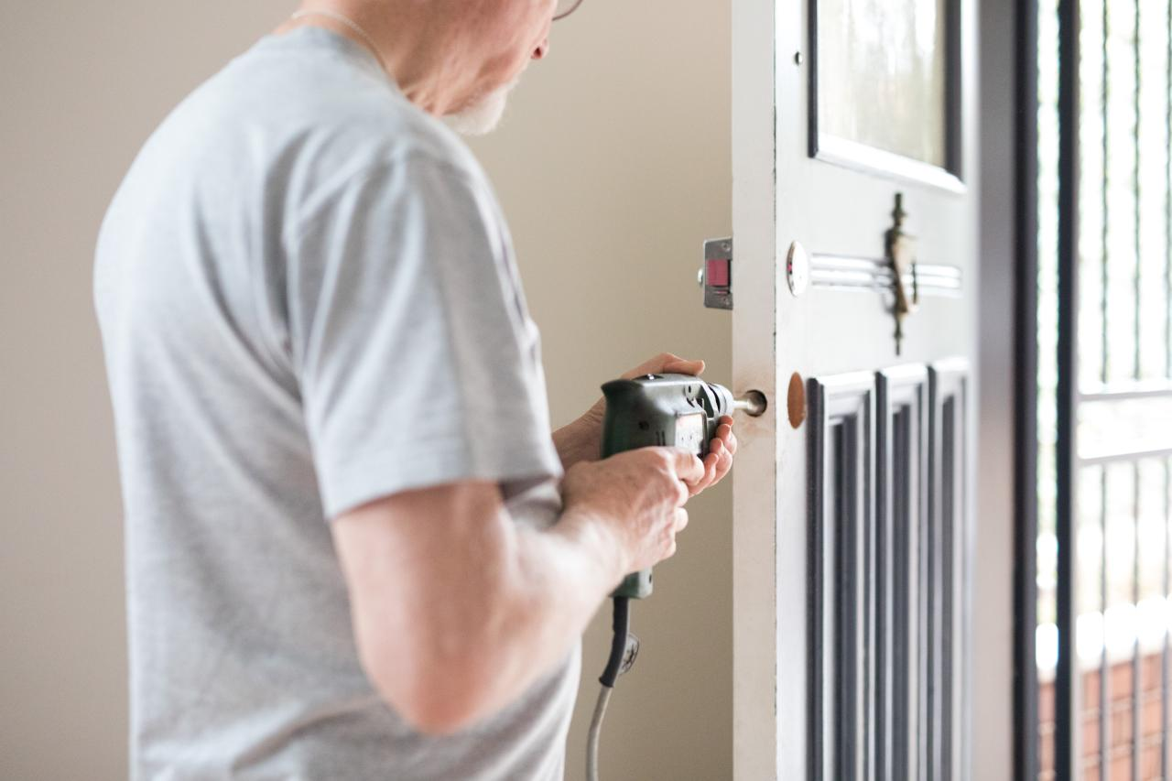

**Landlord’s Duty of Repair**

Landlords of multiple dwellings must keep the apartments and the building’s public areas in “good repair” and clean and free of vermin, garbage, or other offensive material. Landlords are required to maintain electrical, plumbing, sanitary, heating, and ventilating systems, and appliances that the landlord installed (such as refrigerators and stoves) in good and safe working order. All repairs must be made within a reasonable time that may vary depending upon the severity of the repairs. In New York City, the landlord is required to maintain the public areas in a clean and sanitary condition (*NYC Admin. Code§ 27-2011*). Tenants should bring complaints to the attention of their local housing officials (*Multiple Dwelling Law §78 and §80; Multiple Residence Law §174.*) The Multiple Dwelling Law applies to cities with a population of 325,000 or more and the Multiple Residence Law applies to cities with less than 325,000 and to all towns and villages.



**Lead-Based Paint**

In New York, landlords should maintain their properties to reduce the likelihood that young children will be exposed to dangerous lead-based paint. Although limits on the level of lead in paint used in homes were imposed by New York City in 1960, by New York State in 1970, and by the federal Consumer Product Safety Commission in 1978, paint with lead levels higher than those limits remains on the walls and other surfaces of many apartments and homes built before those limits were imposed. Federal law requires landlords to disclose known information about lead-based paint or lead-based paint hazards before a lease becomes effective and all leases must include a warning statement about lead-based paint for all properties built prior to 1978. Federal law also mandates that landlords give a pamphlet to their tenants about how to protect themselves from possible lead exposure in their homes.

In performing any work that disturbs lead-based paint in applicable apartments and common areas, a landlord must hire workers who have completed a training course in lead-safe work practices.

In New York City, landlords must also comply with the New York City Childhood Lead Poisoning Prevention Act, which requires that landlords of buildings with at least 3 apartments constructed before 1960 (or between 1960 and 1978 where the landlord knows there is lead-based paint) ascertain if a child under seven years old lives in an apartment and inspect that apartment for lead-based paint hazards.

Landlords must remove or permanently cover apartment walls and other areas where there is peeling paint or there is friction or impacts that expose the lead and generate lead dust and keep records of all notices, inspections, and repair of lead-based paint hazards and other matters related to lead-based paint law.  Landlords are also required to provide their tenants with a pamphlet prepared by the NYC Department of Health and Mental Hygiene and the NYC Department of Housing Preservation and Development (HPD).

In the City of Rochester, landlords must comply with Rochester’s Lead-Based Paint Poisoning Prevention Ordinance, which requires landlords to conduct a visual inspection of their properties for deteriorating paint as part of their Certificate of Occupancy inspection. In addition, apartments in high-risk areas must also have samples of settled dust tested for lead.

In the City of Buffalo, landlords are required to maintain their properties and take actions to prevent conditions that are conducive to lead poisoning and correct lead hazards using safe work practices (*42 U.S.C.A § 4851; NYC Admin. Code § 27-2056.3; Property Conservation Code of the City of Rochester § 90-50 et seq., Erie County Sanitary Code Article IX*).

*Landlords of multiple dwellings must keep the apartments and the building’s public areas in “good repair” and clean and free of vermin, garbage, or other offensive material.*

*All repairs must be made within a reasonable time that may vary depending upon the severity of the repairs.*



**Safety**

**Smoke Detectors**

Landlords of multiple dwellings must install approved smoke detectors in each apartment, within ten feet of each room used for sleeping. Each smoke detecting device shall include a test device to allow a tenant to ensure that the device is functioning properly. Tenants should test their detectors frequently to make sure they work properly. Smoke detectors should be clearly audible in each of those rooms. Tenants may be asked to reimburse the owner up to $10 for the cost of purchasing and installing each battery-operated detector. During the first year of use, landlords must repair or replace any broken detector if its malfunction is not the tenant’s fault (*Multiple Residence Law § 15; Multiple Dwelling Law § 68; NYC Admin. Code § 27-2045*).  Tenants are responsible for keeping fresh batteries in the smoke detector.

**Carbon Monoxide Detectors**

Landlords of all multiple dwellings, including those owned as a condominium or cooperative, used as a residence, and one-and two-family homes in New York City must provide and install an approved carbon monoxide alarm within 15 feet of the primary entrance to each sleeping room. All multiple dwellings must contain carbon monoxide detectors in accordance with local building codes (*NYC Admin. Code 27-§ 2045; Exec. Law §378*).

New York City landlords must post an HPD-approved form in a common area informing occupants of the requirements of New York City’s carbon monoxide laws. Tenants are responsible for reimbursing the landlord $25.00 within one year for each carbon monoxide alarm that is newly installed. Tenants are responsible for keeping and maintaining the carbon monoxide alarm in good repair. Landlords are responsible for replacing any detectors that are lost, stolen, or become inoperable within the first year of use. (*NYC Admin. Code § 27-2045*).

Combination smoke/carbon monoxide detectors are permitted. A landlord is entitled to be reimbursed a maximum of $50.00 for such combination detectors only when the smoke alarm needs to be replaced. If the smoke alarm is operable and the landlord wishes to replace it with a combined alarm, the landlord can only be reimbursed $25.00.  Tenants are responsible for keeping fresh batteries in the carbon monoxide detector.

**Crime Prevention**

Landlords are required to take minimal precautions to protect against reasonably foreseeable criminal harm. For example, tenants who are victims of crimes in their building or apartment, and who are able to prove that the criminal was an intruder and took advantage of the fact that the entrance to the building was negligently maintained by the landlord, may be able to recover damages from the landlord.

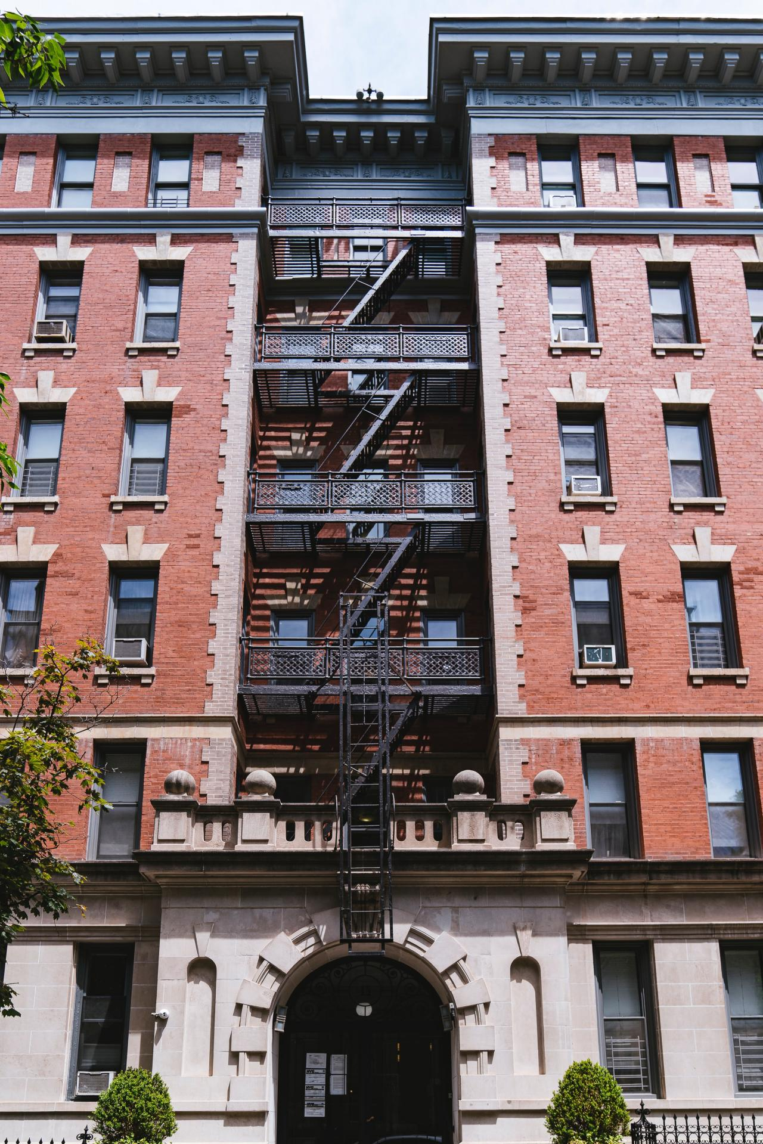

**Entrance Door Locks and Intercoms**

Multiple dwellings which were built or converted to such use after January 1, 1968 must have automatic self-closing and self-locking doors at all entrances. These doors must be kept locked at all times, except when an attendant is on duty. If this type of building contains eight or more apartments it must also have a two-way voice intercom system from each apartment to the front door and tenants must be able to “buzz” open the entrance door for visitors.

Multiple dwellings built or converted to such use prior to January 1, 1968 also must have self-locking doors and a two-way intercom system if requested by a majority of all the apartments. Landlords may recover the cost of providing this equipment from tenants (*Multiple Dwelling Law § 50-a*).

Entrances, stairways and yards of multiple dwellings must be sufficiently lit at night, from sunset to sunrise. The owner is responsible for installing and maintaining lighting in these areas (*NYC Admin. Code § 27-2040; Multiple Dwelling Law § 35; Multiple Residence Law § 109*).

**Lobby Attendant Service**

Tenants of multiple dwellings with eight or more apartments are entitled to maintain a lobby attendant service for their safety and security at their own expense, whenever any attendant provided by the landlord is not on duty (*Multiple Dwelling Law § 50-c*).

**Elevator Mirrors**

There must be a mirror in each self-service elevator in multiple dwellings so that people may see, prior to entering, if anyone is already in the elevator (*Multiple Dwelling Law §51-b; NYC Admin. Code § 27- 2042*).

**Individual Locks, Peepholes and Mailboxes**

Tenants in multiple dwellings can install and maintain their own locks on their apartment entrance doors in addition to the lock supplied by the landlord. The lock may be no more than three inches in circumference, and tenants must provide their landlord with a duplicate key upon request. Failure to provide the landlord with a duplicate key if requested can be construed as a violation of a substantial obligation of the tenancy and can lead to eviction proceedings. Any lease provision requiring a tenant to pay additional rent or other charges for the installation of an additional lock is void as against public policy and unenforceable (*Multiple Dwelling Law § 51-c*).

The landlord must provide a peephole in the entrance door of each apartment. Landlords of multiple dwellings in New York City must also install a chain-door guard on the entrance door to each apartment, to permit partial opening of the door (*Multiple Dwelling Law § 51-a; NYC Admin. Code § 27-2043*).

United States Postal regulations require landlords of buildings containing three or more apartments to provide secure mail boxes for each apartment unless the management has arranged to distribute the mail to each apartment. Landlords must keep the mail boxes and locks in good repair.

**Window Guards**

Landlords in New York City must install window guards at the request of a tenant and in any apartment in which a child under the age of ten resides, whether requested or not.

Landlords are required to provide tenants with a form stating whether there are children residing in a household and to request installation of window guards. Tenants are required to notify their landlord when they have children of this age living in their apartment, or if they provide child care services in the apartment. Tenants may not refuse installation. Once window guards are installed, the tenant must not take down, make alterations to, or remove any part of the guard. Landlords in New York City must install Department of Health and Mental Hygiene-approved window guards. If an object more than five inches in diameter can fit through, over or under a window guard, then it is not installed properly. All approved window guards have a manufacturer’s approval number imprinted on a vertical stile of the guard, and must be appropriate for the type of window in which they are being installed (*NYC Health Code § 131.15; NYC Admin. Code § 27-2043.1*).

Windows giving access to fire escapes are excluded. Protective guards must also be installed on the windows of all public hallways. Landlords must give tenants an annual notice about their rights to window guards and must provide this information in a lease rider. Rent controlled and stabilized tenants may be charged up to $10 per window guard (*NYC Health Code § 131.15*).

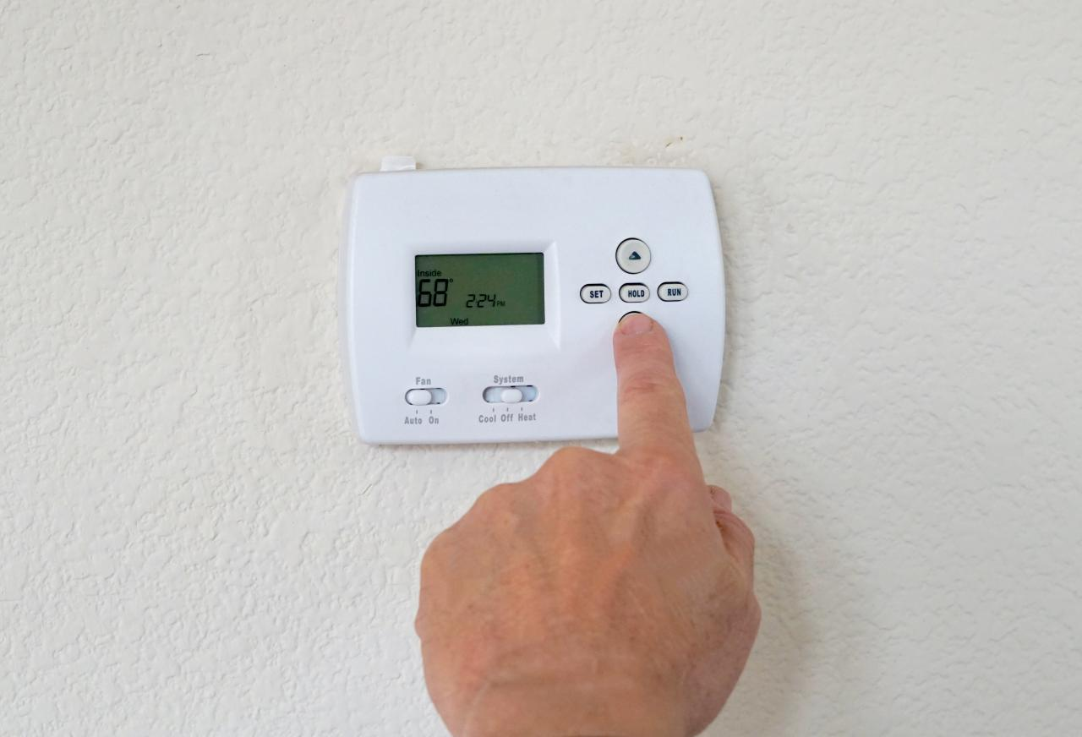

**Utility Services**

**Heating Season**

Heat must be supplied from October 1 through May 31 to tenants in multiple dwellings. If the outdoor temperature falls below 55°F between the hours of six a.m. and ten p.m., each apartment must be heated to a temperature of at least 68°F. If the outdoor temperature falls below 40°F between the hours of ten p.m. and six a.m., each apartment must be heated to a temperature of at least 55°F. Local regulations may require higher temperatures during these times. (*Multiple Dwelling Law § 79; Multiple Residence Law § 173; NYC Admin. Code § 272029*).

**Truth in Heating**

Before signing a lease requiring payment of individual heating and cooling bills, prospective tenants are entitled to receive a complete set or summary of the past two years’ bills from the landlord. These copies must be provided free upon written request (*Energy Law § 17-103*).

**Hot Water**

Landlords must provide all tenants of multiple dwellings with both hot and cold water. Localities can designate temperatures. In NYC, hot water must register at or above a constant temperature of 120 degrees at the tap. If a tub or shower is equipped with an anti-scald valve that prevents the hot water temperature from exceeding 120 degrees, the minimum hot water temperature for that tub or shower is 110 degrees (*Multiple Dwelling Law § 75; Multiple Residence Law § 170; NYC Admin. Code § 27-2031*).

**Continuation of Utility Service**

When the landlord of a multiple dwelling is delinquent in paying utility bills, the utility must give advanced written notice to tenants and to certain government agencies of its intent to discontinue service. Service may not be discontinued if tenants pay the landlord’s current bill directly to the utility company. Tenants can deduct these charges from future rent payments.

The Public Service Commission can assist tenants with related problems. If a landlord of a multiple dwelling fails to pay a utility bill and service is discontinued, landlords may be liable for compensatory and punitive damages (*Real Property Law § 235-a; Public Service Law § 33*).

**Oil Payments**

Tenants in oil-heated multiple dwellings may contract with an oil dealer, and pay for oil deliveries to their building, when the landlord fails to ensure a sufficient fuel supply. These payments are deductible from rent. Local housing officials have lists of oil dealers who will make fuel deliveries under these circumstances (*Multiple Dwelling Law § 302-c; Multiple Residence Law § 305-c*).

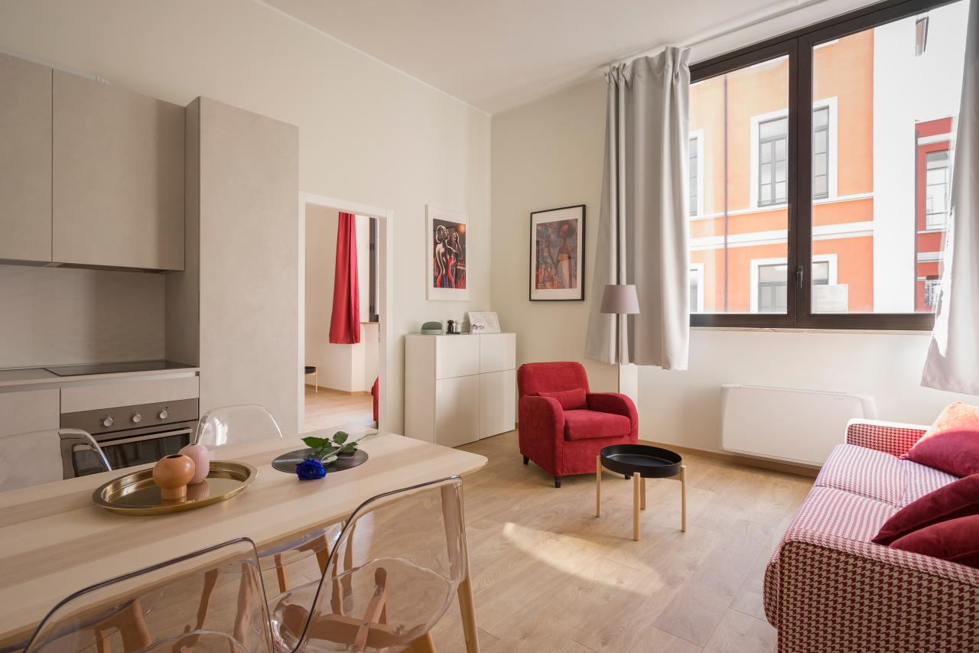

**Tenants’ Personal Protections**

**Tenant Organizations**

Tenants have a legal right to organize. They may form, join, and participate in tenant organizations for the purpose of protecting their rights. Landlords must permit tenant organizations to meet, at no cost, in any community or social room in the building, even if the use of the room is normally subject to a fee. Tenant organization meetings are required to be held at reasonable times and in a peaceful manner which does not obstruct access to the premises (*Real Property Law § 230*).

**Retaliation**

It is illegal for landlords in New York to retaliate against tenants for participating in tenant organizations. It is also illegal for landlords in New York to retaliate against tenants who make a good faith complaint to them or to a government agency about violations of health and safety laws, issues with habitability or non-repair of the premises, violations of rights under a lease, or rent gouging.

It is presumed that a landlord is retaliating if:

* Within one year of a tenant’s complaint, the landlord substantially alters the terms of a tenant’s rental agreement. This includes: refusing to continue to rent to you; failing to renew a lease after your lease has expired; or offering a new lease with an unreasonable rent increase; or
* Within one year of making a good faith complaint, your landlord brings an eviction case against the tenant. If the tenant informs the court that the landlord initiated the eviction proceeding within one year of the tenant’s good faith complaint, the law requires that the landlord to demonstrate that the eviction isn’t retaliatory. The eviction proceeding will be terminated if the landlord fails to prove that the eviction was not retaliatory.

The effect of the presumption requires the landlord to establish a nonretaliatory motive for their actions by a preponderance of the evidence.  Failure to rebut the presumption of retaliation may result in requiring that the tenant be offered a new lease or renewal of up to a year with only a “reasonable” increase.

Tenants may collect damages from landlords who violate this law, which applies to all rentals except owner-occupied dwellings with fewer than four units (*Real Property Law § 223-b*).

**Right to Privacy**

Tenants have the right to privacy within their apartments. A landlord, however, may enter a tenant’s apartment with reasonable prior notice, and at a reasonable time, and with the tenant’s consent, either to provide routine or agreed upon repairs or services, or in accordance with the lease. If the tenant unreasonably withholds consent, the landlord may seek a court order to permit entry. In an emergency, such as a fire or water leak, the landlord may enter the apartment without the tenant’s consent or prior notice. A landlord may not interfere with the installation of cable television facilities (*Public Service Law § 228)*.

**Disabilities**

Landlords are required to provide reasonable accommodations for tenants with disabilities so that they may enjoy equal access to and use of housing accommodations. A “reasonable accommodation” is a policy or rule change that is related to a tenant’s specific disability and does not impose extremely high costs on a landlord or cause harm or discomfort to other tenants, such as permitting a tenant who is blind or has a psychological disability to have a guide dog or a companion animal, despite a building’s “no pets” policy (*42 U.S.C.A § 3604(f)(3)*.

Additionally, a landlord may not refuse to permit, reasonable structural modifications of existing premises occupied by a tenant with a disability, if such modifications may be necessary to afford the tenant full use of the premises and are undertaken at the expense of the tenant. Such modifications may include building a ramp or installing grab bars in the bathroom.  
  
However, the landlord may require a tenant to agree to restore the interior of the premises to the condition that existed before the modification as a condition of granting permission (*42 U.S.C.A. §3604(f) (3))*.

Tenants with disabilities who need accommodations should notify their landlord and request the necessary accommodations. Though such a request is not required to be in writing, it is often helpful should any dispute arise. A landlord may request documentation from a health care professional attesting to the disability and describing any functional limitations that arise. A tenant with a disability who thinks a landlord has unreasonably refused a reasonable accommodation request should contact the U.S. Department of Housing and Urban Development (HUD).

**Discrimination**

Landlords may not refuse to rent to, renew the lease of, or otherwise discriminate against, any person or group of persons because of race, creed, color, national origin, sex, disability, age, AIDS or HIV status, alcoholism, marital status or familial status. In New York City, tenants are further protected against discrimination with respect to lawful occupation, sexual orientation, partnership status, and immigration status. Further, New York State landlords are prohibited from discriminating against tenants based on lawful source of income, which includes income from social security or any form of federal, state, or local public assistance including Section 8 vouchers (*Executive Law § 296(5); NYC Admin. Code § 8-107*).

Landlords may not discriminate against any person who has children living with them by refusing to rent an apartment or by insisting upon unfavorable lease terms because the person has children. In addition, a landlord may not require that tenants remain childless during their tenancy. These restrictions do not apply to housing units for senior citizens that are subsidized or insured by the federal government. In addition, a lease may not require that tenants remain childless during their tenancy (*Real Property Law §237; Real Property Law §237-a)*.

An aggrieved party should contact HUD within one year from the alleged discriminatory housing practice occurs or ceases. In New York City, an aggrieved party may file a complaint with the NYC Commission on Human Rights within one year from the date on which the discriminatory act occurred. An aggrieved party may also choose to sue for damages against a landlord who violates this law and may recover attorney’s fees if successful (*NYC Admin. Code § 8-109; 42 U.S.C.A.§3610(a) (1)*.

**Harassment**

A landlord is prohibited from any action intended to force a tenant out of an apartment or to compel a tenant to give up any rights granted the tenant by law. No landlord, or any party acting on the landlord’s behalf, may interfere with the tenant’s privacy, comfort, or quiet enjoyment of the apartment. Harassment may take the form of physical or verbal abuse, willful denial of services, disruptive construction or renovation projects that interfere with health, safety, and use of an apartment, or multiple instances of frivolous litigation. If a landlord lies or deliberately misrepresents the law to a tenant, this may also constitute harassment. Severe harassing conduct may constitute unlawful eviction and landlords may be subject to both civil and criminal penalties, in the form of a class A misdemeanor for harassment under *Real Property Law § 768*.

Rent regulated tenants who feel they have been victimized by harassment should contact DHCR. In NYC, Landlords found guilty of harassment are subject to fines of up to $2,000 for the first offense and up to $10,000 for each subsequent offense. Under certain circumstances, harassment of a rent regulated tenant may constitute a class E felony (*Penal Law§ 241.05; NYC Admin Code §§ 27-2004, 27-2005*).

New York City tenants have additional recourse against harassment. Tenants may bring a claim in housing court and the court may issue restraining orders against landlords if violations have been found (*NYC Admin Code § 27-2115*).



**Pets**

Tenants may keep pets in their apartments unless their lease specifically prohibits it. Landlords may be able to evict tenants who violate a lease provision prohibiting pets. In multiple dwellings in New York City and Westchester County, a no-pet lease clause is deemed waived where a tenant “openly and notoriously” keeps a pet for at least three months and the owner of the building or the owner’s agent had knowledge of this fact. However, this protection does not apply to public housing or where the animal causes damage, is a nuisance, or substantially interferes with other tenants (*NYC Admin. Code§ 272009.1(b); Westchester County Laws, Chapter 695.11)*.

Tenants who are blind or deaf are permitted to have guide dogs or service dogs regardless of a no-pet clause in their lease. Also, tenants with a chronic mental illness are permitted to have emotional assistance animals (*NY Civil Rights Law § 47-b*).

Tenants may keep pets in their apartments unless their lease specifically prohibits it. Landlords may be able to evict tenants who violate a lease provision prohibiting pets.

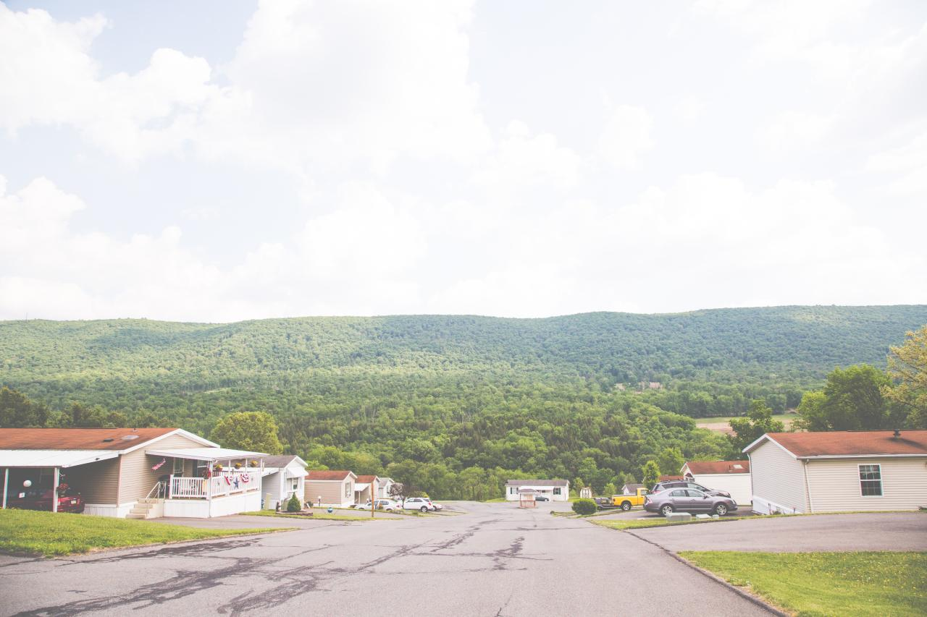

**Manufactured and Mobile Homes**

**Limiting Rent Increases**

In most cases, rent increases including the lot rent and any fees or utilities, are limited to 3%, but park owners can raise the rent by up to 6% if the increase is determined to be “justifiable.” If the park owner asks for a rent increase that is more than 3%, renters can challenge the increase in court. The judge will determine whether the increase is justifiable.

All manufactured home park leases must include a rider regarding tenant rights.



**Rent-to-Own-Protections**

Anyone entering into a rent-to-own agreement with a manufactured home park owner must be provided with a contract that clearly describes:

* The terms of the contract;
* All fees, rent, or other charges due during the life of the contract;
* The fair market value of the manufactured home; and
* The responsibility of the manufactured home park owner to cover major repairs and improvements during the rental period.

Every rent-to-own contract must state that until the title to the property is transferred, the tenant is occupying a rented home. It must also state that until that time, the park owner is responsible for keeping the home in habitable condition; making all major repairs and improvements; and keeping it free from conditions that would be dangerous to the tenant’s health and safety.

Once a year, rent to own tenants are entitled to an itemized account of all payments made in relation to the rent-to-own contract. If the lease is terminated by the park owner, the owner must pay back all payments made pursuant to the rent-to-own contract.

**Restrictions on Fees**

Manufactured home park owners can collect late charges on rent payments only if a late charge provision exists in the lease or manufactured home park rules, but late charges cannot be collected on rent payments received within 10 days of the due date. Late charges cannot be compounded and are not considered to be additional rent.

A manufactured home park owner cannot demand that a tenant pay attorneys’ fees unless they are awarded those fees by a court order.

**Notice of Changes of Use**

If a park owner wants their current residents to leave because they are changing the manufactured home park to another use, the park owner cannot begin eviction proceedings until two years after they provide notice that they intend to change the use of the park.

If the resident owns their manufactured home and the park owner wants them to leave because they intend to change the use of the land, they must pay the resident a stipend of up to $15,000 in order to compensate them for the cost of moving the home.

If you believe a manufactured home park owner is not following the law, you may contact the New York State Department of Homes and Community Renewal (([hcr.ny.gov](https://hcr.ny.gov/)). The Manufactured Homes Complaint Program Hotline is (800) 432-4210.

*Once a year, rent to own tenants are entitled to an itemized account of all payments made in relation to the rent-to-own contract. If the lease is terminated by the park owner, the owner must pay back all of the rent-to-own payments that were made.*



**Finding an Apartment**

**Real Estate Brokers**

A consumer may retain a real estate broker to find a suitable apartment. New York State licenses real estate brokers and salespersons. Brokers charge a commission for their services, which is usually a stated percentage of the first year’s rent. The amount of the commission is not set by law and should be negotiated between the parties. The broker must assist the client in finding and obtaining an apartment before a commission may be charged. The fee should not be paid until the client is offered a lease signed by the landlord.

Under the Rent Stabilization Code, a broker’s commission may be considered “rent” in excess of legal rent when there is too close of a business or financial connection between the broker and the landlord (*9 NYCRR § 2525.1*). Complaints against real estate brokers should be directed to the New York Department of State (*Real Property Law, §442-e*).

**Apartment Information and Sharing Agencies**

Apartment listing services that charge a fee for providing information about the location and availability of apartments and rooms for rent must be licensed by the state (Real Property Law § 446-b). The fees charged by these firms may not exceed one month’s rent and must be deposited in an escrow account. When the information provided by the firms does not result in a rental, the entire amount of any pre-paid fee, less $15.00, must be returned to the prospective tenant. Criminal prosecution for violations of this law may be brought by the Attorney General (*Real Property Law § 446-h*).

**Fees**

Before signing a lease, the most a landlord can charge for a credit and background check is $20. The landlord must provide the applicant a copy of the credit or background check, as well as an invoice from the company that performed it. A landlord is prohibited from charging an applicant for a credit or background check if they fail to provide the applicant with a copy. The applicant can provide their own background or credit check to avoid any fees, as long as the background or credit check was performed within the past 30 days.

**Key Money:** It is illegal to charge a prospective tenant additional fees– commonly called “key money”– above the lawful rent and security deposit, for preference in renting a vacant apartment. Key money is not to be confused with fees that may be legally charged by a licensed real estate broker (*Penal Law § 180.55*).

**Tenant Screening Reports or “Tenant Blacklists”**

A landlord cannot deny a tenant applicant an apartment, rental home, or any other type of rental based on a past legal conflict with a landlord. For example, a landlord cannot deny an applicant an apartment because they sued their previous landlord to make repairs.

If a landlord rejects your application after using a tenant screening service report containing prior tenant-landlord cases or relies on review of those records themselves, the law assumes that you were rejected because of this history.  You may complain to the Attorney General’s office and the landlord may have to pay a fine between $500-$1,000.00 to the State if they cannot give a good reason for denying you.  (*Real Property Law (“RPL”) § 227-f.*).